ASSIGNMENT-2
Network Lab Experiments

Name: INDHUJA JAYAN
Class:S5 CSE A
Roll No:35

SOCKET PROGRAMMING PRACTICE ASSIGNMENTS

QUESTION 1– Hello Client-Server (Beginner)
Server code
#include <stdio.h>
#include <string.h>
#include <winsock2.h>
#define PORT 8080
int main()
{
WSADATA wsa;
SOCKET serverSocket, clientSocket;
struct sockaddr_in serverAddr, clientAddr;
int addrSize;
char buffer[1024];
WSAStartup(MAKEWORD(2, 2), &wsa);
serverSocket = socket(AF_INET, SOCK_STREAM, 0);
serverAddr.sin_family = AF_INET;
serverAddr.sin_addr.s_addr = INADDR_ANY;
serverAddr.sin_port = htons(PORT);
bind(serverSocket, (struct sockaddr *)&serverAddr,
sizeof(serverAddr));
listen(serverSocket, 5);
printf("Server is waiting for connection...\n");
addrSize = sizeof(clientAddr);
clientSocket = accept(serverSocket,
(struct sockaddr *)&clientAddr,
&addrSize);
recv(clientSocket, buffer, sizeof(buffer), 0);

printf("Client says: %s\n", buffer);
strcpy(buffer, "Hello Client");
send(clientSocket, buffer, strlen(buffer) + 1, 0);
closesocket(clientSocket);
closesocket(serverSocket);
WSACleanup();
return 0;
}
Client
#include <stdio.h>
#include <string.h>
#include <winsock2.h>
#define PORT 8080
int main()
{
WSADATA wsa;
SOCKET clientSocket;
struct sockaddr_in serverAddr;
char buffer[1024];
WSAStartup(MAKEWORD(2, 2), &wsa);
clientSocket = socket(AF_INET, SOCK_STREAM, 0);
serverAddr.sin_family = AF_INET;
serverAddr.sin_port = htons(PORT);
serverAddr.sin_addr.s_addr = inet_addr("127.0.0.1");
connect(clientSocket,
(struct sockaddr *)&serverAddr,
sizeof(serverAddr));
strcpy(buffer, "Hello Server");
send(clientSocket, buffer, strlen(buffer) + 1, 0);
recv(clientSocket, buffer, sizeof(buffer), 0);

printf("Server says: %s\n", buffer);
closesocket(clientSocket);
WSACleanup();
return 0;
}
OUTPUT
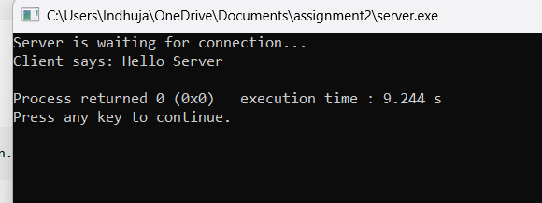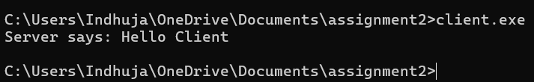
QUESTION 2– Arithmetic Server
SERVER
#include <stdio.h>
#include <winsock2.h>

#define PORT 8080

int main()
{
WSADATA wsa;
SOCKET serverSocket, clientSocket;
struct sockaddr_in serverAddr, clientAddr;
int addrSize;

int a, b;
int sum, difference, product;
float division;

// Initialize Winsock
WSAStartup(MAKEWORD(2, 2), &wsa);

// Create socket
serverSocket = socket(AF_INET, SOCK_STREAM, 0);

// Server address
serverAddr.sin_family = AF_INET;
serverAddr.sin_addr.s_addr = INADDR_ANY;
serverAddr.sin_port = htons(PORT);

// Bind
bind(serverSocket, (struct sockaddr *)&serverAddr,
sizeof(serverAddr));

// Listen
listen(serverSocket, 5);

printf("Server is waiting for connection...\n");

// Accept client
addrSize = sizeof(clientAddr);

clientSocket = accept(serverSocket,
(struct sockaddr *)&clientAddr,
&addrSize);

// Receive two integers
recv(clientSocket, (char *)&a, sizeof(a), 0);
recv(clientSocket, (char *)&b, sizeof(b), 0);

// Perform calculations
sum = a + b;
difference = a - b;
product = a * b;

if (b != 0)
division = (float)a / b;
else
division = 0;

// Send results
send(clientSocket, (char *)&sum, sizeof(sum), 0);
send(clientSocket, (char *)&difference, sizeof(difference), 0);
send(clientSocket, (char *)&product, sizeof(product), 0);
send(clientSocket, (char *)&division, sizeof(division), 0);

closesocket(clientSocket);
closesocket(serverSocket);

WSACleanup();

return 0;
}
CLIENT

#include <stdio.h>
#include <winsock2.h>
#define PORT 8080
int main()
{
WSADATA wsa;
SOCKET clientSocket;
struct sockaddr_in serverAddr;
int a, b;
int sum, difference, product;
float division;
WSAStartup(MAKEWORD(2, 2), &wsa);
clientSocket = socket(AF_INET, SOCK_STREAM, 0);
// Server address
serverAddr.sin_family = AF_INET;
serverAddr.sin_port = htons(PORT);
serverAddr.sin_addr.s_addr = inet_addr("127.0.0.1");
// Connect to server
connect(clientSocket,
(struct sockaddr *)&serverAddr,
sizeof(serverAddr));
// Input
printf("Enter two integers: ");
scanf("%d %d", &a, &b);
// Send integers
send(clientSocket, (char *)&a, sizeof(a), 0);
send(clientSocket, (char *)&b, sizeof(b), 0);
// Receive results
recv(clientSocket, (char *)&sum, sizeof(sum), 0);
recv(clientSocket, (char *)&difference, sizeof(difference), 0);
recv(clientSocket, (char *)&product, sizeof(product), 0);
recv(clientSocket, (char *)&division, sizeof(division), 0);
// Display results
printf("\nAddition = %d\n", sum);
printf("Subtraction = %d\n", difference);
printf("Multiplication = %d\n", product);
if (b != 0)
printf("Division = %.2f\n", division);
else
printf("Division = Cannot divide by zero\n");
closesocket(clientSocket);
WSACleanup();
return 0;
}

OUTPUT
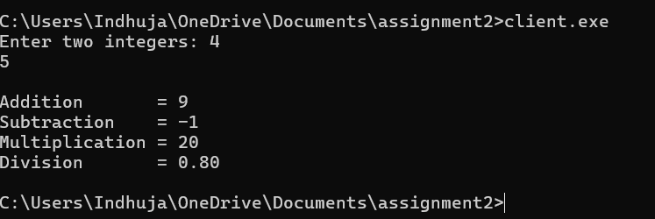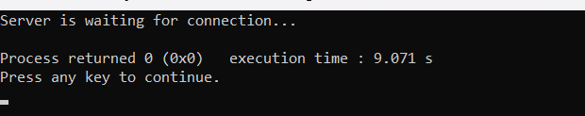

QUESTION 3– String Processing Server
SERVER
#include <stdio.h>
#include <string.h>
#include <ctype.h>
#include <winsock2.h>
#define PORT 8080
int main()
{
WSADATA wsa;
SOCKET serverSocket, clientSocket;
struct sockaddr_in serverAddr, clientAddr;
int addrSize;
char str[1024];
char uppercase[1024];
char reverse[1024];
int length;
int i;
WSAStartup(MAKEWORD(2, 2), &wsa);
serverSocket = socket(AF_INET, SOCK_STREAM, 0);
serverAddr.sin_family = AF_INET;
serverAddr.sin_addr.s_addr = INADDR_ANY;
serverAddr.sin_port = htons(PORT);
bind(serverSocket, (struct sockaddr *)&serverAddr,
sizeof(serverAddr));
listen(serverSocket, 5);
printf("Server is waiting for connection...\n");
addrSize = sizeof(clientAddr);
clientSocket = accept(serverSocket,
(struct sockaddr *)&clientAddr,
&addrSize);
recv(clientSocket, str, sizeof(str), 0);
length = strlen(str);
for (i = 0; i < length; i++)
{
uppercase[i] = toupper((unsigned char)str[i]);
}
uppercase[length] = '\0';
for (i = 0; i < length; i++)
{
reverse[i] = str[length - 1 - i];
}
reverse[length] = '\0';
send(clientSocket, (char *)&length, sizeof(length), 0);
send(clientSocket, uppercase, sizeof(uppercase), 0);
send(clientSocket, reverse, sizeof(reverse), 0);
closesocket(clientSocket);
closesocket(serverSocket);
WSACleanup();
return 0;
}
CLIENT
#include <stdio.h>
#include <string.h>
#include <winsock2.h>
#define PORT 8080
int main()
{
WSADATA wsa;
SOCKET clientSocket;
struct sockaddr_in serverAddr;
char str[1024];
char uppercase[1024];
char reverse[1024];
int length;
// Initialize Winsock
WSAStartup(MAKEWORD(2, 2), &wsa);
// Create socket
clientSocket = socket(AF_INET, SOCK_STREAM, 0);
// Server address
serverAddr.sin_family = AF_INET;
serverAddr.sin_port = htons(PORT);
serverAddr.sin_addr.s_addr = inet_addr("127.0.0.1");
// Connect to server
connect(clientSocket,
(struct sockaddr *)&serverAddr,
sizeof(serverAddr));
// Input string
printf("Enter a string: ");
fgets(str, sizeof(str), stdin);
// Remove newline
str[strcspn(str, "\n")] = '\0';
// Send string
send(clientSocket, str, sizeof(str), 0);
// Receive results
recv(clientSocket, (char *)&length, sizeof(length), 0);
recv(clientSocket, uppercase, sizeof(uppercase), 0);
recv(clientSocket, reverse, sizeof(reverse), 0);
// Display results
printf("\nLength = %d\n", length);
printf("Uppercase = %s\n", uppercase);
printf("Reverse = %s\n", reverse);
closesocket(clientSocket);
WSACleanup();
return 0;
}
OUTPUT
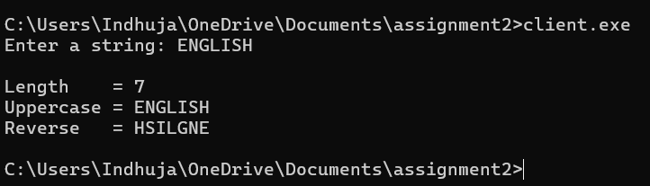

QUESTION 4– Array Processing Server
SERVER
#include <stdio.h>
#include <winsock2.h>
#define PORT 8080
int main()
{
WSADATA wsa;
SOCKET serverSocket, clientSocket;
struct sockaddr_in serverAddr, clientAddr;
int addrSize;

int N;
int arr[100];
int sum = 0;
int max, min;
float average;

/* Start Winsock */
WSAStartup(MAKEWORD(2, 2), &wsa);
/* Create socket */
serverSocket = socket(AF_INET, SOCK_STREAM, 0);
if (serverSocket == INVALID_SOCKET)
{
printf("Socket creation failed\n");
return 1;
}
/* Server address */
serverAddr.sin_family = AF_INET;
serverAddr.sin_port = htons(PORT);
serverAddr.sin_addr.s_addr = INADDR_ANY;
/* Bind */
if (bind(serverSocket,
(struct sockaddr *)&serverAddr,
sizeof(serverAddr)) == SOCKET_ERROR)
{
printf("Bind failed\n");
closesocket(serverSocket);
WSACleanup();
return 1;
}
/* Listen */
listen(serverSocket, 5);
printf("Server waiting for client...\n");
/* Accept client */
addrSize = sizeof(clientAddr);

clientSocket = accept(serverSocket,
(struct sockaddr *)&clientAddr,
&addrSize);
if (clientSocket == INVALID_SOCKET)
{
printf("Accept failed\n");
closesocket(serverSocket);
WSACleanup();
return 1;
}
printf("Client connected!\n");
/* Receive N */
recv(clientSocket, (char *)&N, sizeof(N), 0);
/* Receive array */
recv(clientSocket,
(char *)arr,
sizeof(int) * N,
0);
/* Initialize maximum and minimum */
max = arr[0];
min = arr[0];
/* Calculate sum, maximum and minimum */
for (int i = 0; i < N; i++)
{
sum = sum + arr[i];

if (arr[i] > max)
max = arr[i];
if (arr[i] < min)
min = arr[i];
}
/* Calculate average */
average = (float)sum / N;
/* Send results */
send(clientSocket, (char *)&sum, sizeof(sum), 0);
send(clientSocket, (char *)&average, sizeof(average), 0);
send(clientSocket, (char *)&max, sizeof(max), 0);
send(clientSocket, (char *)&min, sizeof(min), 0);
printf("Results sent to client.\n");
/* Close sockets */
closesocket(clientSocket);
closesocket(serverSocket);
WSACleanup();
return 0;
}
CLIENT
#include <stdio.h>
#include <winsock2.h>
#define PORT 8080
int main()
{
WSADATA wsa;
SOCKET clientSocket;
struct sockaddr_in serverAddr;

int N;
int arr[100];
int sum, max, min;
float average;
/* Start Winsock */
WSAStartup(MAKEWORD(2, 2), &wsa);
/* Create socket */
clientSocket = socket(AF_INET, SOCK_STREAM, 0);
if (clientSocket == INVALID_SOCKET)
{
printf("Socket creation failed\n");
return 1;
}

/* Server address */
serverAddr.sin_family = AF_INET;
serverAddr.sin_port = htons(PORT);
serverAddr.sin_addr.s_addr = inet_addr("127.0.0.1");
/* Connect to server */
if (connect(clientSocket,
(struct sockaddr *)&serverAddr,
sizeof(serverAddr)) == SOCKET_ERROR)
{
printf("Connection failed\n");
closesocket(clientSocket);
WSACleanup();
return 1;
}

printf("Connected to server!\n");
/* Input N */
printf("Enter number of elements: ");
scanf("%d", &N);
/* Input array */
printf("Enter %d elements:\n", N);
for (int i = 0; i < N; i++)
{
scanf("%d", &arr[i]);
}
/* Send N */
send(clientSocket, (char *)&N, sizeof(N), 0);
/* Send array */
send(clientSocket, (char *)arr, sizeof(int) * N, 0);
/* Receive results */
recv(clientSocket, (char *)&sum, sizeof(sum), 0);
recv(clientSocket, (char *)&average, sizeof(average), 0);
recv(clientSocket, (char *)&max, sizeof(max), 0);
recv(clientSocket, (char *)&min, sizeof(min), 0);
/* Display results */
printf("\n--- Results ---\n");
printf("Sum = %d\n", sum);
printf("Average = %.2f\n", average);
printf("Maximum = %d\n", max);
printf("Minimum = %d\n", min);
/* Close socket */
closesocket(clientSocket);
WSACleanup();
return 0;
}
OUTPUT
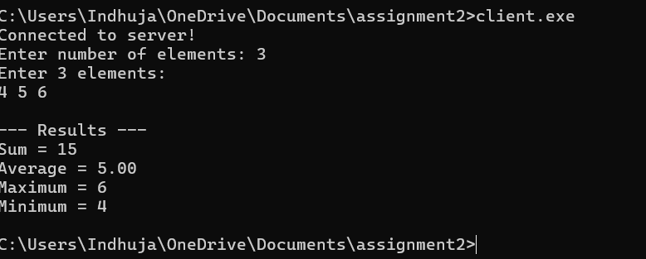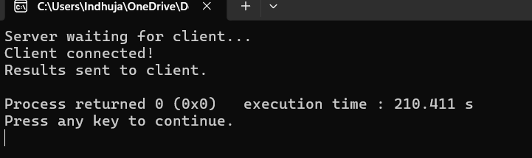
QUESTION 5– Matrix Analyzer
SERVER
#include <stdio.h>
#include <winsock2.h>
#define PORT 8080
int main()
{
WSADATA wsa;
SOCKET serverSocket, clientSocket;
struct sockaddr_in serverAddr, clientAddr;
int addrSize;
int n;
int matrix[10][10];

int i, j;
int sum = 0;
int trace = 0;
int isDiagonal = 1;
int isUpper = 1;
int isLower = 1;
char matrixType[30];
// Initialize Winsock
WSAStartup(MAKEWORD(2, 2), &wsa);
// Create socket
serverSocket = socket(AF_INET, SOCK_STREAM, 0);
// Server address
serverAddr.sin_family = AF_INET;
serverAddr.sin_addr.s_addr = INADDR_ANY;
serverAddr.sin_port = htons(PORT);
// Bind
bind(serverSocket, (struct sockaddr *)&serverAddr,
sizeof(serverAddr));
// Listen
listen(serverSocket, 5);
printf("Server is waiting for connection...\n");
// Accept client
addrSize = sizeof(clientAddr);
clientSocket = accept(serverSocket,
(struct sockaddr *)&clientAddr,
&addrSize);

// Receive order
recv(clientSocket, (char *)&n, sizeof(n), 0);
// Receive matrix
recv(clientSocket, (char *)matrix, sizeof(matrix), 0);
// Find sum and trace
for (i = 0; i < n; i++)
{
for (j = 0; j < n; j++)
{
sum = sum + matrix[i][j];
if (i == j)
{
trace = trace + matrix[i][j];
}
if (i != j && matrix[i][j] != 0)
{
isDiagonal = 0;
}
if (i > j && matrix[i][j] != 0)
{
isUpper = 0;
}
if (i < j && matrix[i][j] != 0)
{
isLower = 0;
}
}
}

// Determine matrix type
if (isDiagonal)
{
sprintf(matrixType, "Diagonal Matrix");
}
else if (isUpper)
{
sprintf(matrixType, "Upper Triangular Matrix");
}
else if (isLower)
{
sprintf(matrixType, "Lower Triangular Matrix");
}
else
{
sprintf(matrixType, "General Matrix");
}
// Send results
send(clientSocket, matrixType, sizeof(matrixType), 0);
send(clientSocket, (char *)&sum, sizeof(sum), 0);
send(clientSocket, (char *)&trace, sizeof(trace), 0);
closesocket(clientSocket);
closesocket(serverSocket);
WSACleanup();
return 0;
}
CLIENT
#include <stdio.h>
#include <winsock2.h>
#define PORT 8080
int main()
{
WSADATA wsa;
SOCKET clientSocket;
struct sockaddr_in serverAddr;
int n;
int matrix[10][10];
int sum;
int trace;
int i, j;
char matrixType[30];
// Initialize Winsock
WSAStartup(MAKEWORD(2, 2), &wsa);
// Create socket
clientSocket = socket(AF_INET, SOCK_STREAM, 0);
// Server address
serverAddr.sin_family = AF_INET;
serverAddr.sin_port = htons(PORT);
serverAddr.sin_addr.s_addr = inet_addr("127.0.0.1");
// Connect to server
connect(clientSocket,
(struct sockaddr *)&serverAddr,
sizeof(serverAddr));
// Input matrix order
printf("Enter order of square matrix: ");
scanf("%d", &n);
// Input matrix
printf("Enter %d x %d matrix:\n", n, n);
for (i = 0; i < n; i++)
{
for (j = 0; j < n; j++)
{
scanf("%d", &matrix[i][j]);
}
}
// Send order
send(clientSocket, (char *)&n, sizeof(n), 0);
// Send matrix
send(clientSocket, (char *)matrix, sizeof(matrix), 0);
// Receive results
recv(clientSocket, matrixType, sizeof(matrixType), 0);
recv(clientSocket, (char *)&sum, sizeof(sum), 0);
recv(clientSocket, (char *)&trace, sizeof(trace), 0);
// Display results
printf("\nMatrix Type = %s\n", matrixType);
printf("Sum = %d\n", sum);
printf("Trace = %d\n", trace);
closesocket(clientSocket);
WSACleanup();
return 0;
}
OUTPUT
